Tutorial 2

Module Name: Login / Registration Module - Test Plan & RTM
Test Case ID: TC02
Tester Name: Vora Riya

Scenarios:
- Scenario ID: 2a
Scenario
Verify registration with valid details
Test Steps
1. Open Demo Web Shop.
2. Click Register.
3. Enter valid personal details.
4. Enter a new email.
5. Enter same password and confirm password.
6. Click Register.
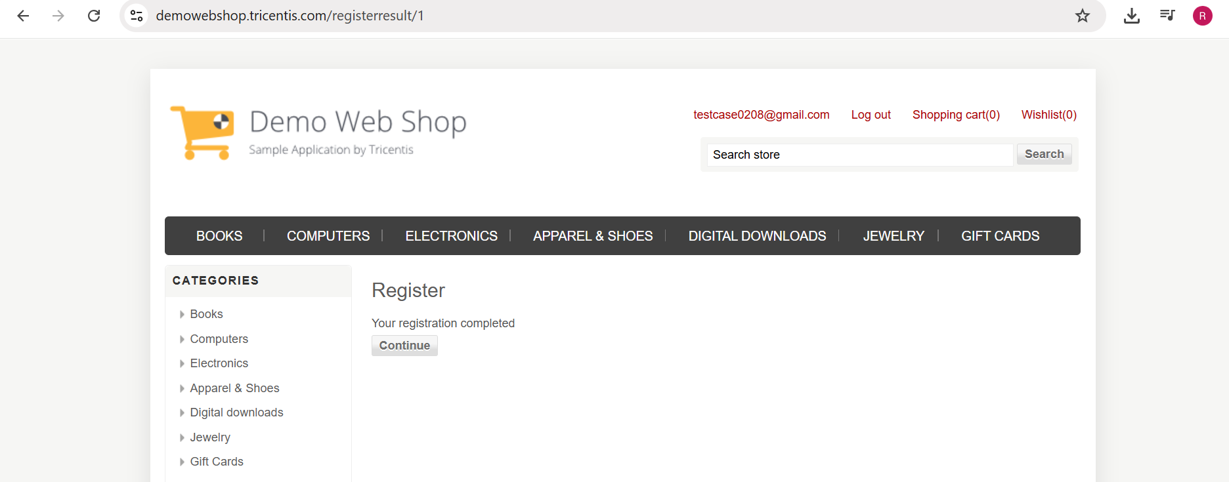

- Scenario ID: 2b
Scenario
Verify registration with mismatched password and confirm password
Test Steps
1. Open Register page.
2. Enter valid personal details.
3. Enter email.
4. Enter password.
5. Enter a different Confirm Password.
6. Click Register.

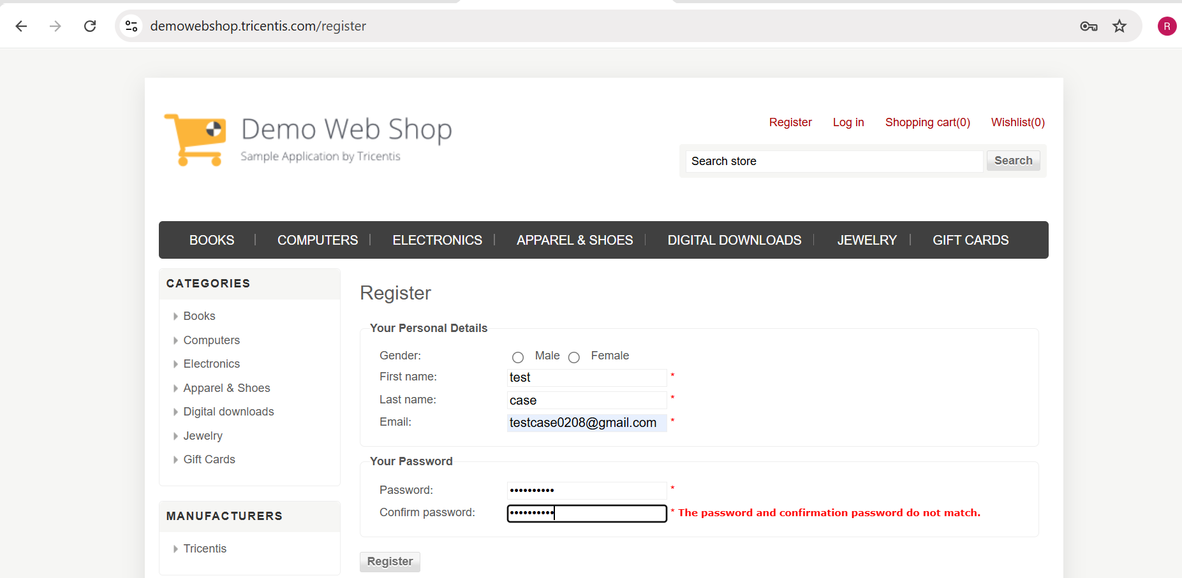

- Scenario ID: 2c
Scenario
Verify registration using an already registered email address
Test Steps
1. Open Register page.
2. Enter valid name details.
3. Enter already registered email.
4. Enter valid matching passwords.
5. Click Register.
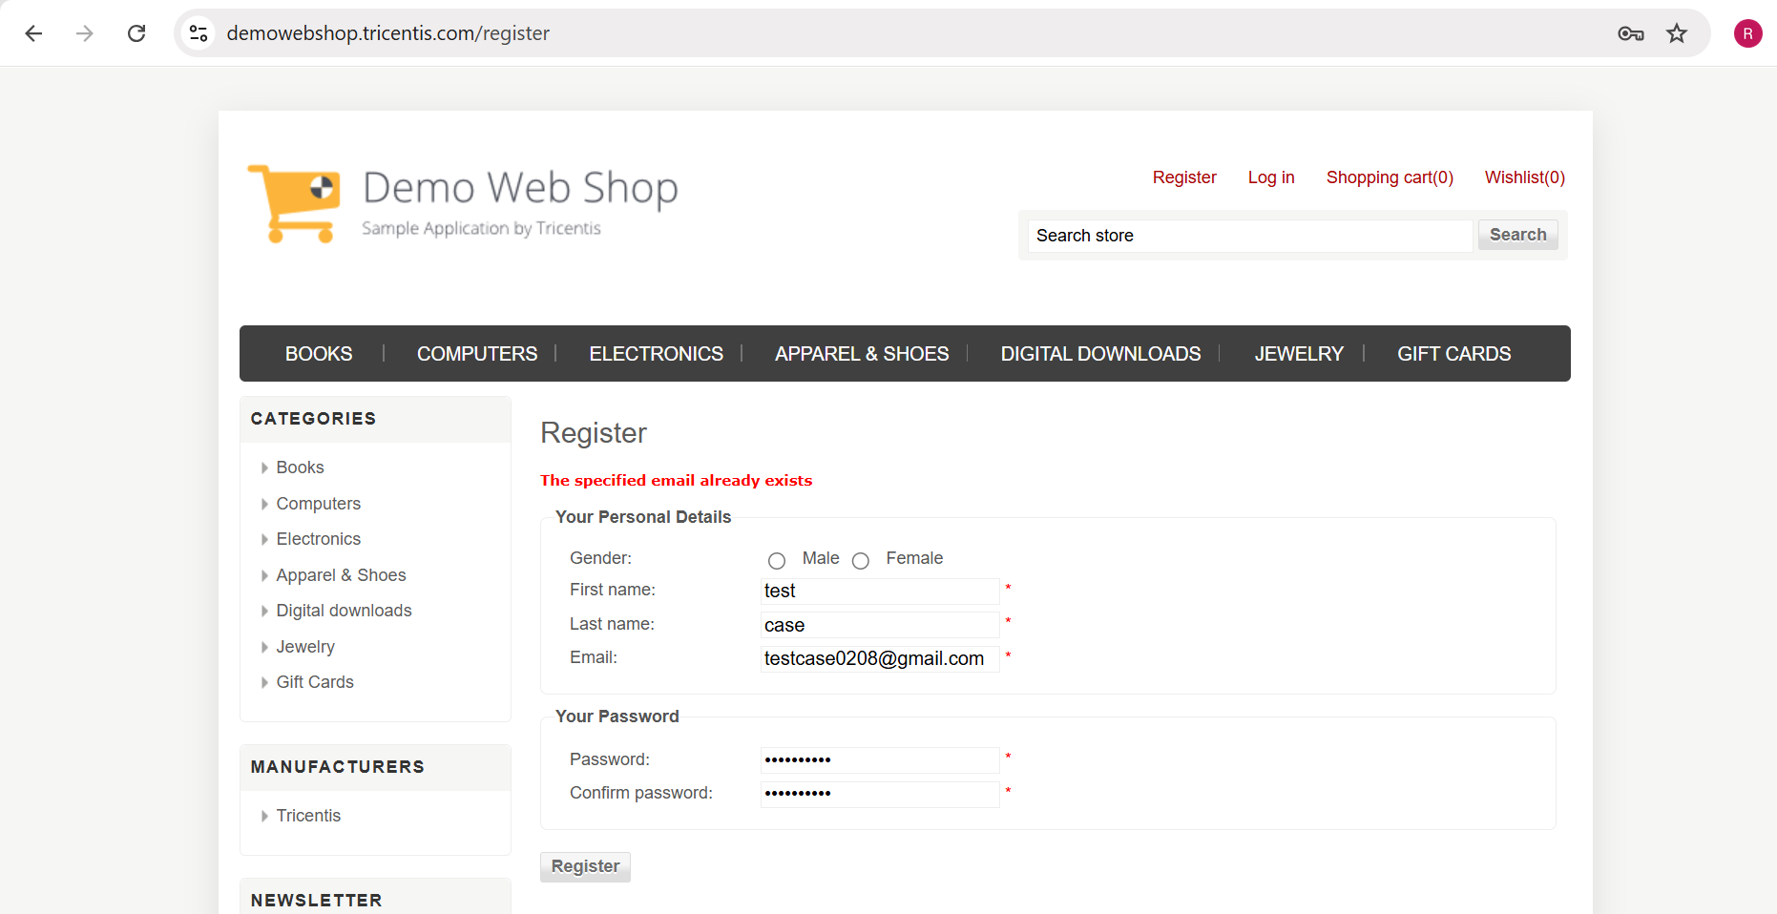

- Scenario ID: 2d
Scenario
Verify login with valid credentials
Test Steps
1. Open Login page.
2. Enter registered email.
3. Enter correct password.
4. Click Log in.
5. Observe the result.

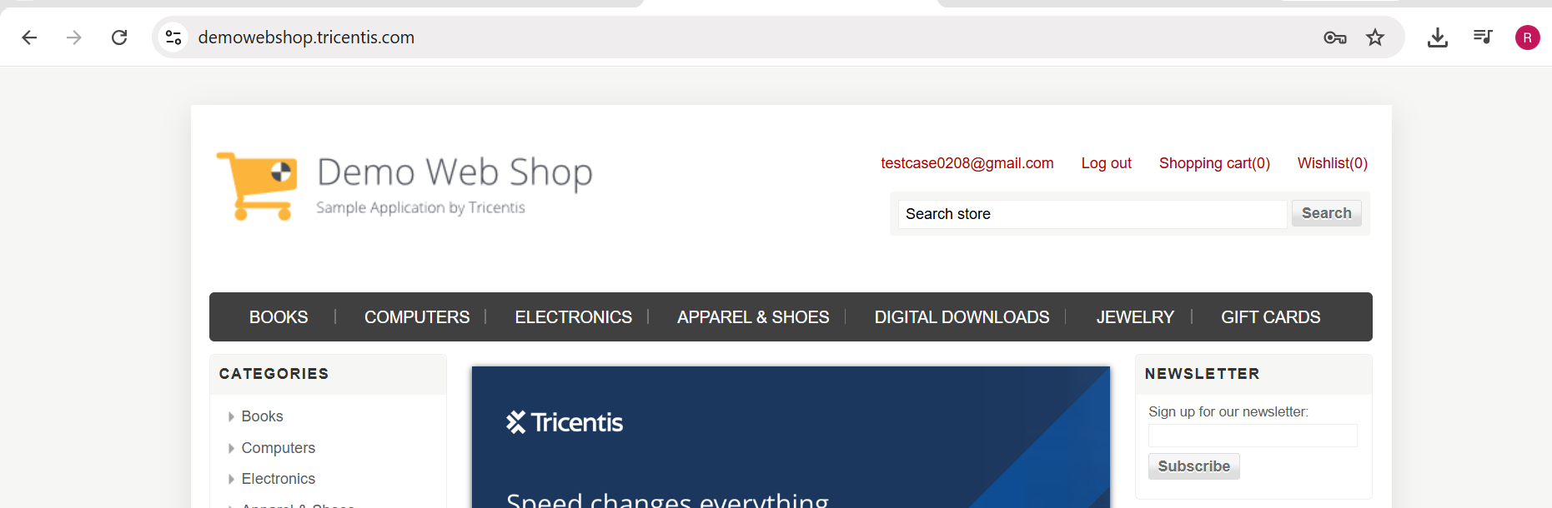

- Scenario ID: 2e
Scenario
Verify login with an unregistered email address
Test Steps
1. Open Login page.
2. Enter unregistered email.
3. Enter password.
4. Click Log in.
5. Observe error.
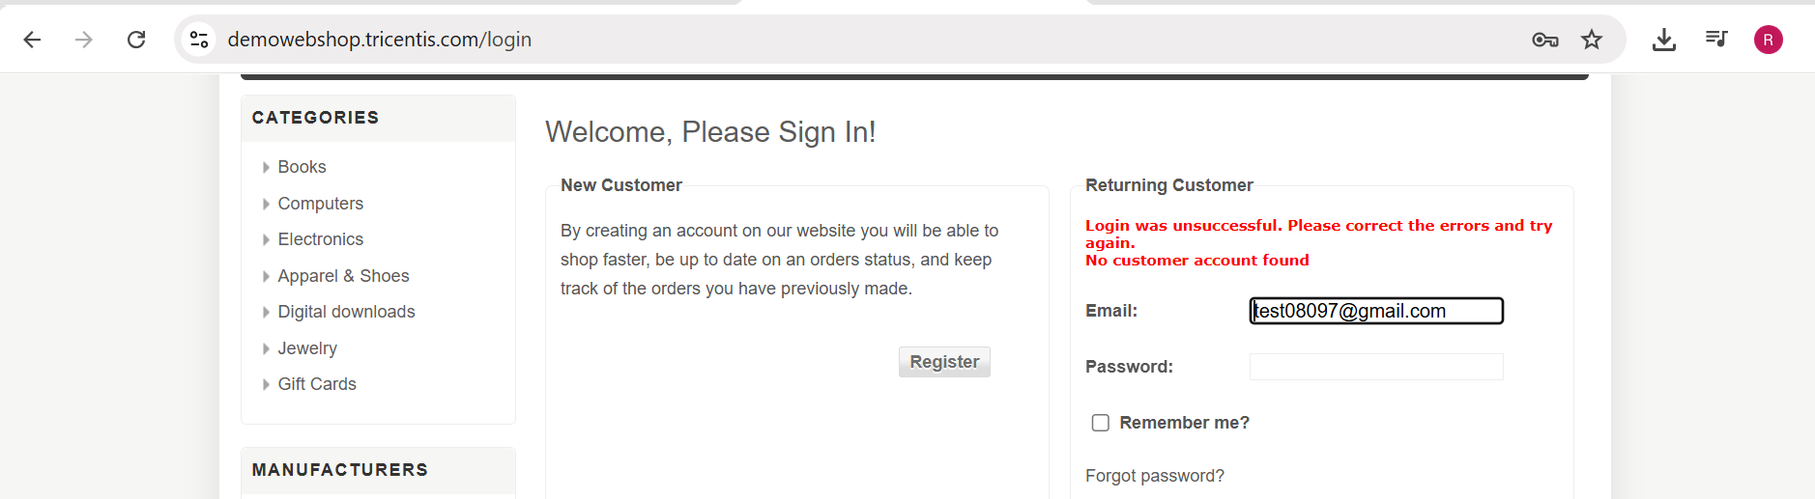

- Scenario ID: 2f
Scenario
Verify login with an invalid password
Test Steps
1. Open Login page.
2. Enter registered email.
3. Enter incorrect password.
4. Click Log in.
5. Observe error.
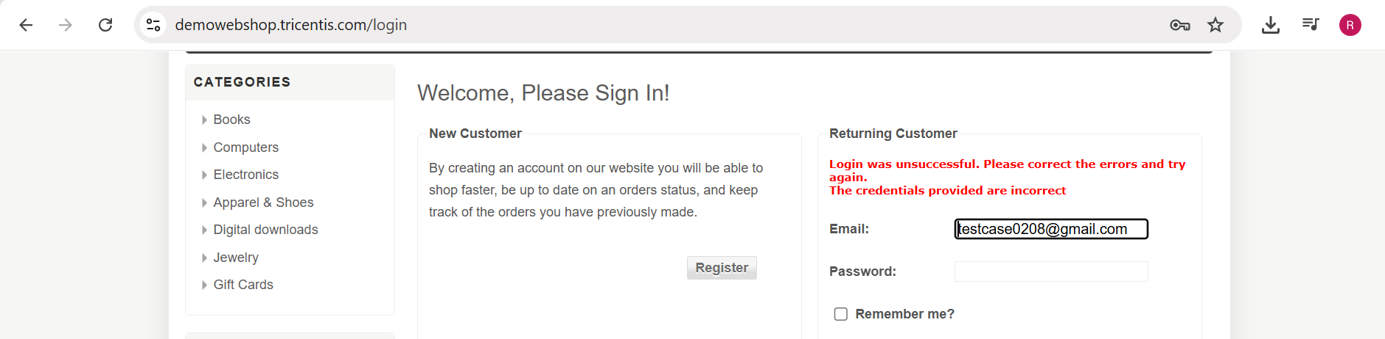

- Scenario ID: 2g
Scenario
Verify login with blank email field
Test Steps
1. Open Login page.
2. Leave Email blank.
3. Enter password.
4. Click Log in.
5. Observe the result.
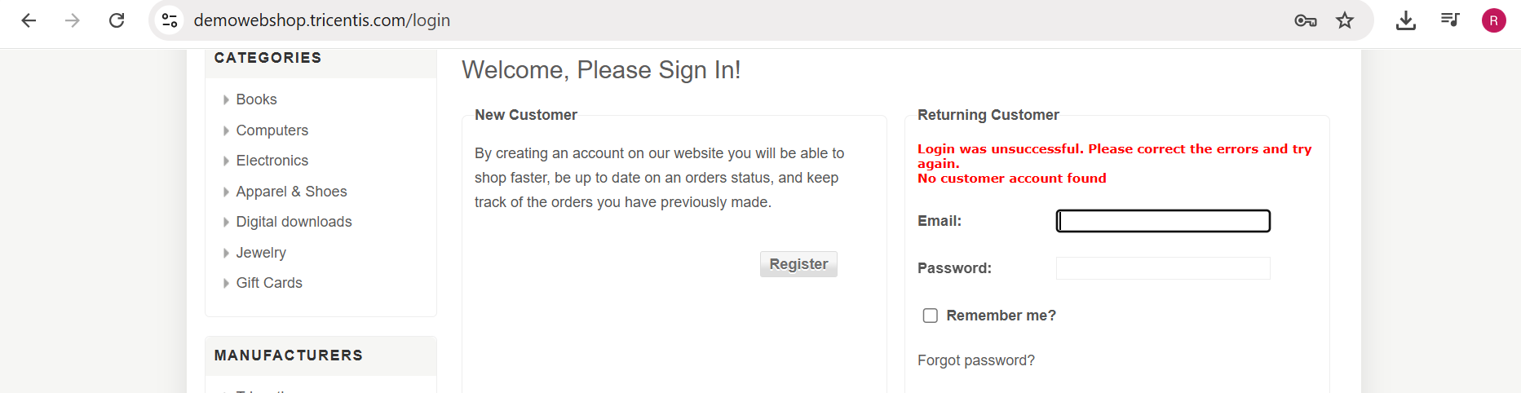

- Scenario ID: 2h
Scenario
Verify Logout functionality
Test Steps
1. Login with valid credentials.
2. Verify user is logged in.
3. Click Log out.
4. Observe resulting page.

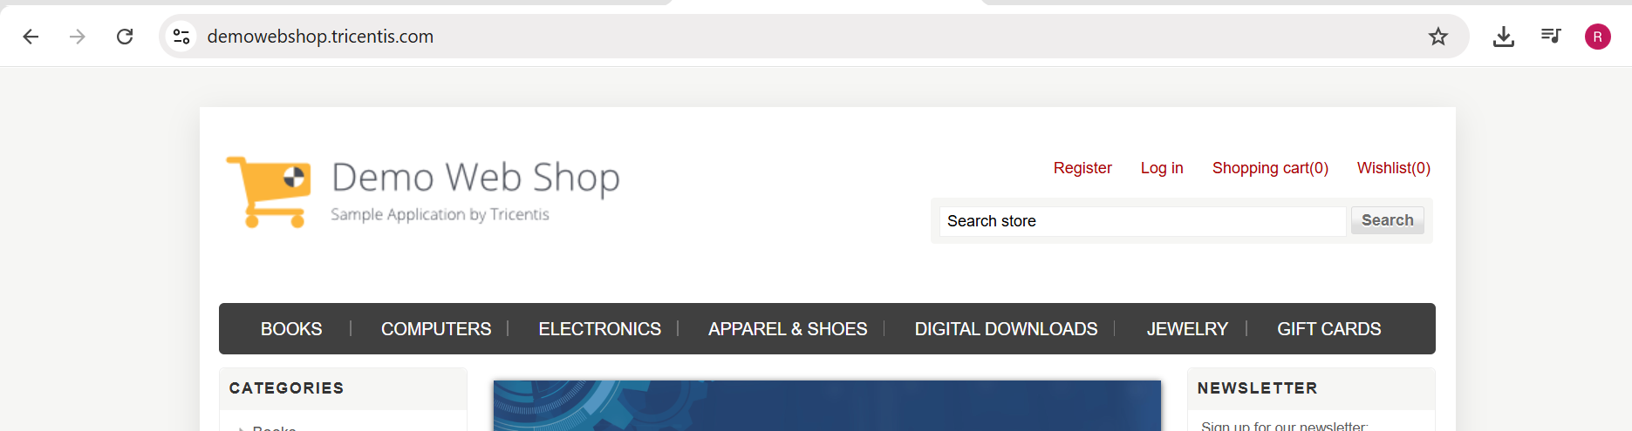

Requirement Traceability Matrix (RTM)

Requirement ID | Requirement | Scenario ID | Test Scenario | Status
REQ-01 | User should be able to register using valid details | 2a | Verify registration with valid details | Pass
REQ-02 | System should validate mismatched passwords | 2b | Verify registration with mismatched password and confirm password | Pass
REQ-03 | System should prevent registration using an existing email | 2c | Verify registration using an already registered email address | Pass
REQ-04 | Registered user should be able to login | 2d | Verify login with valid credentials | Pass
REQ-05 | System should reject an unregistered email | 2e | Verify login with an unregistered email address | Pass
REQ-06 | System should reject an incorrect password | 2f | Verify login with an invalid password | Pass
REQ-07 | System should not allow login with blank email | 2g | Verify login with blank email field | Pass
REQ-08 | Logged-in user should be able to logout | 2h | Verify Logout functionality | Pass

Test Result Summary

Total Test Case | Pass | Fail
8 | 8 | 0

